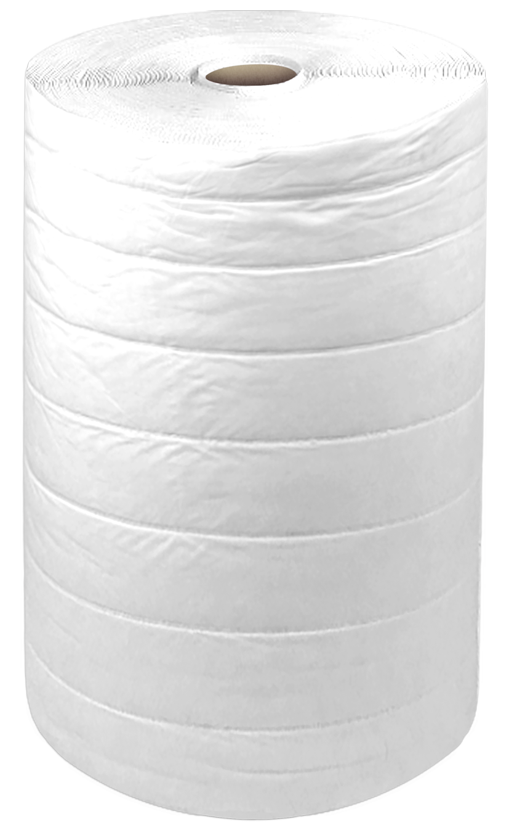
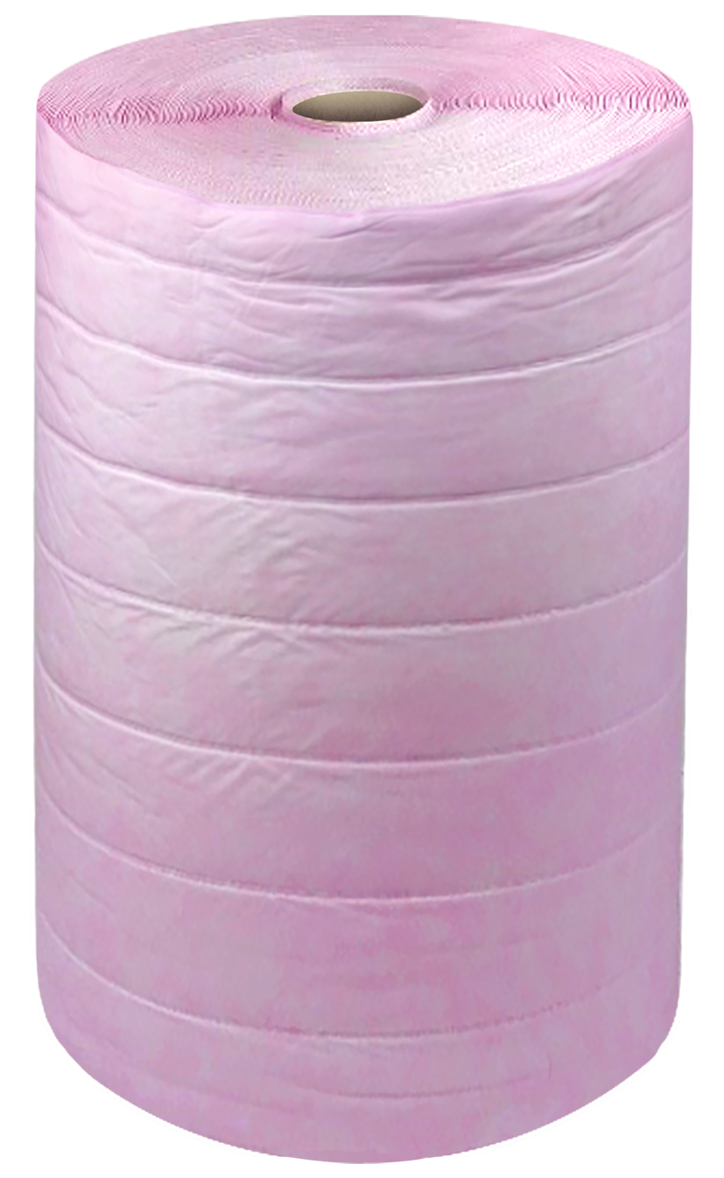
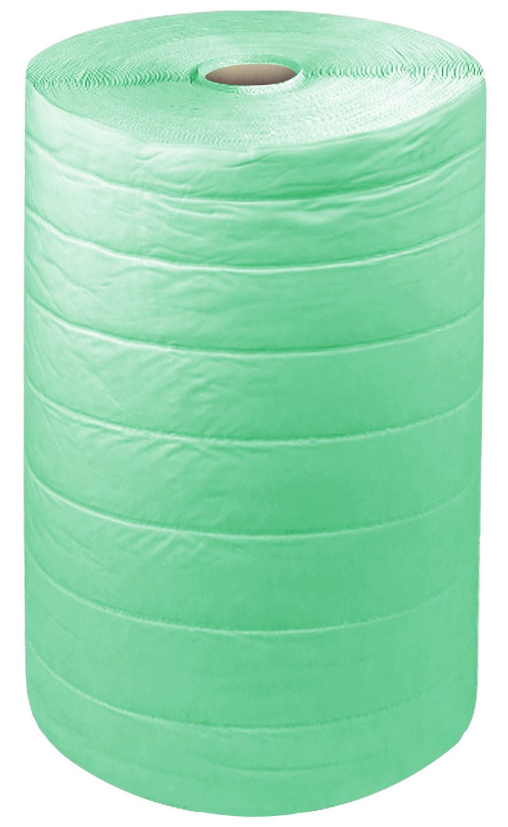
Applications

Synthetic Pocket Media is used in both commercial and industrial applications, as well as hospitals, schools and public buildings.
It is installed in general air conditioning plants, in gas turbine equipment and in computer suites to protect equipment for longer service life.

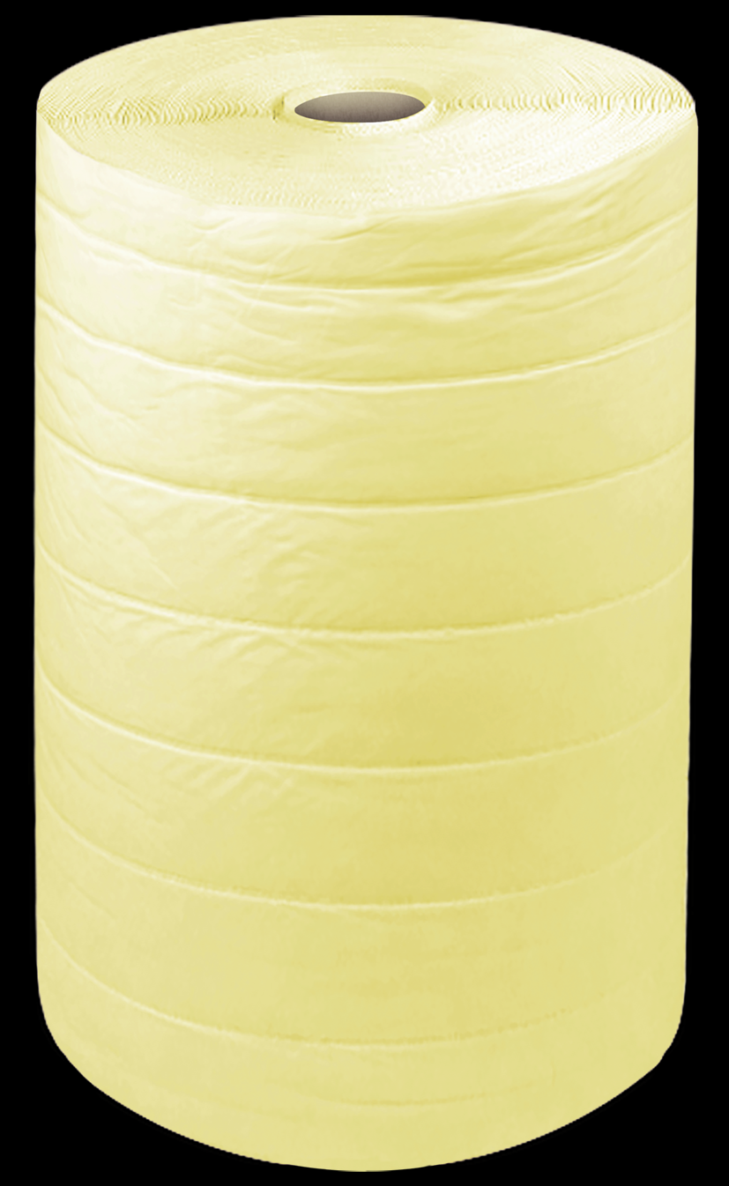
Description

The Synthetic Pocket Media offers high efficiency filtration while maintaining low resistance to air-flow.
Available in F5, F6, F7, F8, F9 efficiencies.

PERFORMANCE DATA
Synthetic Pocket Filter Media, Single Media
PRODUCT CODE |  | F5-FM-700/200 | F6-FM-700/150 | F7-FM-700/150 | F8-FM-700/150 | F9-FM-700/150
EFFICIENCY |  | 45% | 65% | 85% | 90% | 93%
RESISTANCE |  | 6 | 10 | 15 | 20 | 26
COLOUR |  | White | Green | Pink | Light Yellow | Deep Yellow
Pressure Drop  mm/s | 50 | >300 | >250 | >120 | >100 | >70
 | 100 | >550 | >450 | >200 | >180 | >130
 | 200 | >1000 | >800 | >400 | >350 | >250

